# Annexure3b- Complete filing

# INVENTION DISCLOSURE FORM

Details of Invention for better understanding:

**1. TITLE:** **3D Printed Modular Home Construction System.**

**2. INTERNAL INVENTOR(S)/ STUDENT(S):** All fields in this column are mandatory to be filled

|  |  |
| --- | --- |
| A. Full name | JASKIRAT SINGH |
| ­­­­­Mobile Number | 8699383145 |
| Email (personal) | jaskiratsingh7569@gmail.com |
| UID/Registration number | 12323689 |
| Address of Internal Inventors | Lovely Professional University, Punjab-144411, India |
| Signature (Mandatory) |  |
| B. Full name | PATEL KAVY |
| Mobile Number | 7984932104 |
| Email | Patelkavy44@gmail.com |
| UID/Registration number | 12416882 |
| Address of Internal Inventors | Lovely Professional University, Punjab-144411, India |
| Signature (Mandatory) |  |
| C. Full name | TARUN BHARDWAJ |
| Mobile Number | 6398595311 |
| Email | nanubhardwaj92@gmail.com |
| UID/Registration number | 12309956 |
| Address of Internal Inventors | Lovely Professional University, Punjab-144411, India |
| Signature (Mandatory) |  |
| D. Full name | SHRIOM |
| Mobile Number | 9466054951 |
| Email | shriom356@gmail.com |
| UID/Registration number | 12408089 |
| Address of Internal Inventors | Lovely Professional University, Punjab-144411, India |
| Signature (Mandatory) |  |

**EXTERNAL INVENTOR(S): (INVENTORS NOT WORKING IN LPU)**

|  |  |
| --- | --- |
| A. Full name | DR.NIKITA JINDAL |
| Mobile Number | 81949 20087 |
| Email | nikita.jindal17@gmail.com |
| ­­­­­­Address of External Affiliations | Lovely Professional University, Punjab-144411, India |
| Signature (Mandatory) |  |

**3. DESCRIPTION OF THE INVENTION:**

1. **PROBLEM ADDRESSED BY THE INVENTION:**

The traditional construction of residential homes is often slow, expensive, and resource-intensive. Several challenges faced by the construction industry include:

* **High labor costs:** Traditional home construction requires significant manual labor, which can lead to high costs and scheduling delays.
* **Material waste and inefficiency:** Conventional construction methods often produce excess waste and require significant transportation of materials, resulting in higher environmental impact.
* **Time-consuming construction process:** Building a home can take several months to complete, limiting the availability of affordable housing in high-demand areas.
* **Customization limitations:** Traditional construction methods can struggle to accommodate highly personalized or innovative home designs without significant additional costs or delays.
* **Environmental impact:** The construction industry is a major contributor to carbon emissions due to the high energy usage in manufacturing and transporting materials such as cement and steel.

This invention addresses these issues by introducing a **3D printing-based modular construction system** that simplifies the construction process, reduces costs, promotes sustainability, and allows for customization while ensuring structural integrity and energy efficiency.

**B. OBJECTIVE OF THE INVENTION (Provide minimum two);** One objective of this invention is to reduce construction time by streamlining the assembly process through prefabricated modular components. Another aim is to enhance the affordability of housing by leveraging the benefits of 3D printing technology.

Additionally, the invention aims to minimize waste by utilizing precise measurements and reducing the need for excess materials. Furthermore, it aims to provide flexibility in housing design by allowing for easy customization of the modular components.

This system also seeks to improve durability by ensuring that the components are precisely crafted to fit together seamlessly. Moreover, the objective of the invention is to introduce an environmentally friendly alternative to traditional construction methods through the use of sustainable materials in the 3D printing process.

**C. STATE OF THE ART/ RESEARCH GAP/NOVELTY:** Describe your invention fulfil the research gap?

|  |  |  |  |  |
| --- | --- | --- | --- | --- |
| Sr. No. | Patent I’d | Abstract | Research Gap | Novelty |
| 1. Patent Title: 3D Printing Method for Construction of Buildings | US20190276368A1 | The invention relates to a method for constructing buildings using 3D printing technology. The method involves using a large-scale 3D printer to layer building materials such as concrete, polymers, or other composite materials to form walls and structural elements. The system enables precise control of the material deposition, allowing for rapid construction of residential or commercial buildings. This method can be integrated with advanced robotics to automate the process of creating load-bearing walls and other essential structural components of a building. | Traditional construction methods are slow and labor-intensive. This patent addresses the need for faster and more cost-efficient construction methods for homes and buildings. Existing 3D printing methods often require a lot of manual intervention and are limited to small structures. This patent focuses on scalable solutions that can be used for residential and commercial construction, thus addressing the lack of scalability in current 3D printing technologies. | The novelty lies in the integration of 3D printing with robotics to create fully functional building structures, which reduces manual labor and significantly accelerates the construction process. The approach also considers the use of composite materials that could be tailored for different parts of the structure, allowing for better thermal insulation, durability, and aesthetic flexibility. |
| 1. :Method and Apparatus for 3D Printing Construction Materials | US10450276B2 | This patent discloses a method for 3D printing construction materials, focusing on a system that deposits concrete or similar materials through an extrusion process to build a solid structure layer by layer. The method aims to improve the consistency and strength of the printed material while allowing the creation of complex geometries. The system includes a multi-material extruder capable of using different construction materials for different parts of the home (e.g., reinforced concrete for structural walls, light materials for partitions, etc.). | Traditional 3D printers have limitations when it comes to printing with multiple materials simultaneously. This patent fills the gap by integrating multi-material extrusion systems, which enables diverse applications within a single print cycle. Another research gap addressed is the lack of strength and durability in 3D printed construction materials, which this invention addresses by introducing a method for improving the material's mechanical properties and overall integrity. | The key novelty is the multi-material extruder that allows for printing different construction materials within the same layer, enabling the creation of complex structures with varied properties (e.g., stronger walls and lighter interior partitions). Additionally, the patent introduces methods for improving the material strength and thermal properties of 3D printed building components, addressing durability concerns common in earlier 3D printed construction methods |
| 1. 3D Printed Modular Construction System | WO2018082761A1 | This invention relates to a modular construction system that uses 3D printing for the creation of modular components that can be easily assembled into a complete structure. The system utilizes interlocking modules made from 3D printed materials that can be quickly produced on-site and then assembled with minimal manual labor. The modular design allows for flexibility in terms of both | While traditional construction methods require significant manual labor, time, and material waste, existing modular construction techniques often rely on prefabricated components that must be transported to the site. Current 3D printing applications in construction lack a fully integrated modular system that allows for easy on-site assembly with interlocking features, limiting adaptability and scalability. | This invention introduces a **3D-printed modular construction system** that enables on-site fabrication of interlocking components, reducing labor and material waste. The design enhances **structural flexibility, rapid assembly, and customization** while maintaining strength and durability. Unlike existing methods, this system allows for efficient mass production of modular elements using 3D printing, streamlining construction workflows. |

**D. DESCRIPTION:** The invention involves a **3D printed modular home construction system** that employs a combination of innovative techniques in modularity, materials, and automation to create residential homes efficiently, sustainably, and cost-effectively. The system comprises several key components:

1. **3D Printer Design and Capabilities**:
   * The printer is a **large-scale, mobile 3D printer** capable of printing structural components such as walls, floors, roofs, and foundations. It operates using construction-grade materials like **reinforced concrete**, **composite plastics**, and **bio-based composites**.
   * The printer utilizes **precision layering** technology to print large components with high accuracy and strength, ensuring structural integrity and reducing material waste.
2. **Modular Interlocking System**:
   * The printed components are designed to **interlock** or assemble in modular configurations, which simplifies the construction process.
   * Components include **interlocking wall segments**, **pre-formed foundation bases**, and **roofing structures**, all of which are pre-designed in the software to fit together with minimal manual intervention. These modular parts can be produced in parallel and then assembled onsite.
3. **Customized Design**:
   * A specialized **3D modeling software** enables architects and builders to design a home based on specific needs, such as the number of rooms, energy efficiency requirements, and aesthetic preferences. The software optimizes the design for 3D printing, considering factors like weight distribution, material use, and structural strength.
   * The software generates the **complete 3D model** of the house, which includes the entire layout (foundation, walls, roofing, plumbing, and electrical conduits), all ready for printing.
4. **Foundation Printing**:
   * The system prints a **foundation directly on the site**, using a specialized material that is fast-setting and highly durable. This eliminates the need for traditional excavation, formwork, and concrete pouring, allowing for a faster and more sustainable foundation process.
5. **Energy-Efficient Features**:
   * The printed homes can integrate **thermal insulation layers** directly into the walls during printing, improving the home’s energy efficiency.
   * Optional features like **solar panel mounts**, **rainwater harvesting systems**, and pre-installed conduits for **smart home technology** are incorporated into the 3D printing process, offering an all-in-one sustainable building solution.
6. **Automated and Quality-Controlled Printing Process**:
   * The construction process is **automated**, reducing the need for manual labor and minimizing human error. The printer is equipped with built-in sensors and a **quality-control system** that ensures each layer is printed to specification.
   * Real-time data from the printer allows for **continuous monitoring** of the material quality and structural integrity of each printed component.
7. 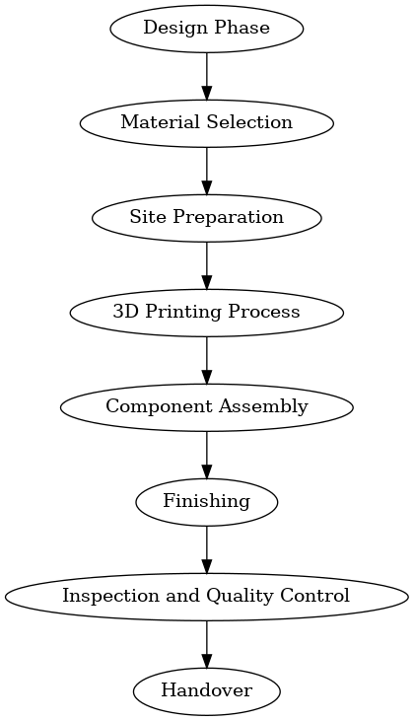

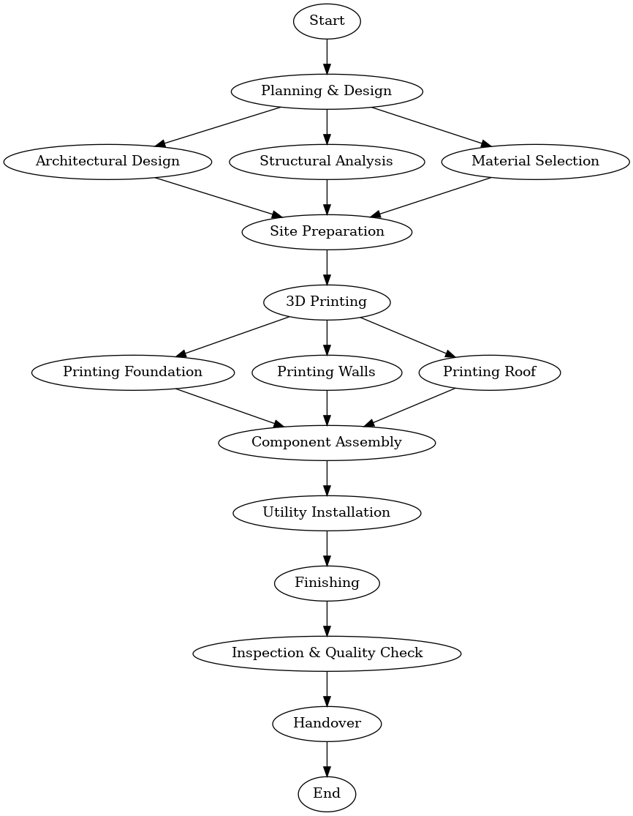

**E. RESULTS AND ADVANTAGES:** **Faster Construction**: The ability to print large-scale components directly on-site dramatically reduces construction time, allowing homes to be completed in a fraction of the time it would take using traditional methods. This can lead to faster housing solutions in high-demand areas

* **Lower Costs**: The system minimizes the need for expensive labor and reduces material waste, making home construction more affordable. The use of a 3D printer also eliminates costs associated with transporting heavy building materials to the site.
* **Customization and Flexibility**: The system allows for fully customizable homes based on specific user requirements (e.g., layout, energy performance, aesthetic preferences).
* The 3D printing software offers a high degree of flexibility in design without significantly increasing the cost.
* **Sustainability**: By using recycled materials and reducing waste, this system supports sustainable construction practices. The ability to print directly on-site also reduces the environmental impact of transporting materials.
* **Energy Efficiency**: The built-in insulation and options for renewable energy integrations (e.g., solar panel mounts) enhance the energy performance of the home, reducing long-term energy consumption.
* **Scalability**: The modular approach allows for rapid scaling of the construction process, making it suitable for both individual homes and large housing projects.
* **Reduced Environmental Impact**: The system reduces the overall carbon footprint of home construction by using eco-friendly materials, lowering energy consumption, and minimizing construction waste.

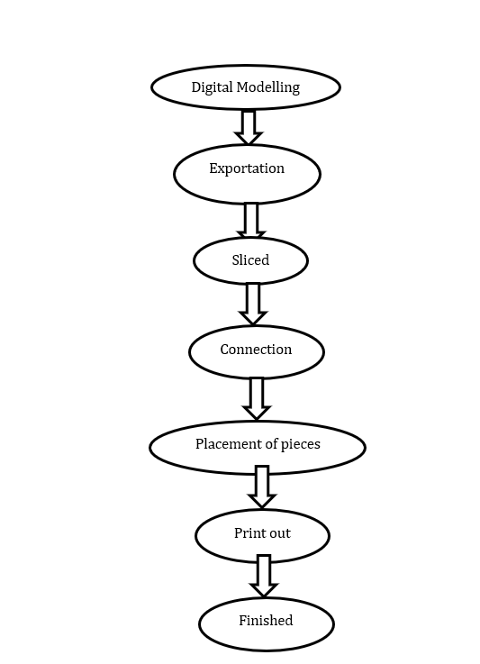

**F. EXPANSION:** Moreover, the expansion of this system could lead to increased accessibility to housing in remote or disaster-stricken areas due to its efficiency and quick construction capabilities. Additionally, the incorporation of smart technology into the housing units could further enhance their functionality and sustainability, paving the way for advanced integrated solutions in the future.

**G. WORKING PROTOTYPE/ FORMULATION/ DESIGN/COMPOSITION:**

A working prototype of the 3D printer has been developed, capable of printing walls, foundations, and roofing elements using concrete and composite materials. The printer operates with an **automated software platform** that allows users to design homes with varying layouts and energy needs. The prototype has successfully printed a small-scale model of a house, including walls, a floor slab, and a roof structure, demonstrating the system’s viability in real-world applications.

**H. EXISTING DATA:** Initial testing of the 3D printed components shows:

* A **reduction in material waste** by 30% compared to traditional construction methods.
* **40% faster build time** for the structure compared to traditional homebuilding timelines.
* The printed home exhibits **comparable or better structural integrity** than conventionally built homes, based on material testing and load-bearing analysis.
* **Energy efficiency improvements** with integrated insulation, resulting in an estimated **20% reduction in long-term energy consumption** compared to typical homes built with conventional materials.

This data supports the feasibility of the 3D printed modular home system and its potential to disrupt the construction industry with faster, more cost-effective, and environmentally sustainable building solutions.

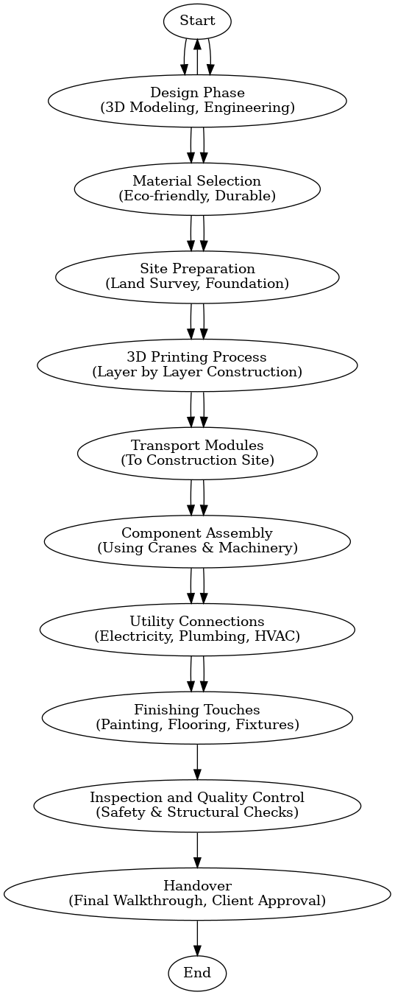

1. **USE AND DISCLOSURE (IMPORTANT):** Please answer the following questions:

|  |  |  |
| --- | --- | --- |
| 1. Have you described or shown your invention/ design to anyone or in any conference? | YES ( ) | NO ( ) |
| 1. Have you made any attempts to commercialize your invention (for example, have you approached any companies about purchasing or manufacturing your invention)? | YES ( ) | NO ( ) |
| 1. Has your invention been described in any printed publication, or any other form of media, such as the Internet? | YES ( ) | NO ( ) |
| 1. Do you have any collaboration with any other institute or organization on the same? Provide name and other details. | YES ( ) | NO ( ) |
| 1. Name of Regulatory body or any other approvals if required. | YES ( ) | NO ( ) |

5. Provide links and dates for such actions if the information has been made public (Google, research papers, YouTube videos, etc.) before sharing with us.

6. Provide the terms and conditions of the MOU also if the work is done in collaboration within or outside university (Any Industry, other Universities, or any other entity).

7. Potential Chances of Commercialization.

8. List of companies which can be contacted for commercialization along with the website link.

9. Any basic patent which has been used and we need to pay royalty to them.

10**. FILING OPTIONS:** Please indicate the level of your work which can be considered for provisional/ complete/ PCT filings (Mandatory to mention).

11. **KEYWORDS:** Please provide right keywords for searching your invention.

**NO OBJECTION CERTIFICATE**

This is to certify that Lovely Professional University, Punjab-144411, India or its associates shall have no objection if Lovely Professional University files an IPR Patent entitled "**3D Printed Modular Home Construction System**." including the name(s) of Jaskirat Singh , Patel Kavy , Tarun Bhardwaj ,Shriom as inventors who is(are) student(s).

Further Lovely Professional University, Punjab-144411, India shall not provide any financial assistance in respect of said IPR nor shall raise any objection later with respect to filing or commercialization of the said IPR or otherwise claim any right to the patent/invention at any stage.

x

(Authorised Signatory)